**Theoretical background**

* Affect Misatribution Task’s (AMP) is used in research on the basis that it is an implicit measure.
* Effect assumed to be mediated by *misattribution* and emitted under the operating conditions of *unawareness* and/or *unintentionality* (Payne & Lundberg, 2014).
* We reexamine if AMP effects are in fact ‘implicit’ in the sense of operating without a person’s intention or awareness.
* If not, then:
  + Not mediated by misattribution
  + Not an implicit measure
  + Not that attractive to use in future research

**Empirical Background**

* Payne et al. (2013, Experiment 3): Traditional AMP vs. Skip AMP.
  + Three response options: evaluate as positive, negative, or skip on the basis that I was influenced by the prime.
  + No differences observed between Traditional AMP and Skip AMP.
  + Concluded that Traditional AMP effect is therefore driven by unaware & unintentional responding.
* Problems:
  + Compound response conflates evaluates evaluation & influence
  + Study was underpowered, used non-significant differenes as evidence for equivalence. -> biased towards supporting the hypothesis
* Useful:
  + Established that Payne considers unaware and unintentional to be equivalent
  + Established an evidence bar: Skip AMP defined as acceptiable source of supporting evidence for the misattribution account, so results from other highly similar tasks must also be accepted.

**Experiments**

*Predictions*

|  |  |  |  |
| --- | --- | --- | --- |
| Experiment | Task 1 | Task 2 | Sample |
| 1 | - | Positive-Negative IA-AMP |  |
| 2 | Positive-Negative AMP | Positive-Negative IA-AMP |  |
| 3 | **Politics** AMP | Positive-Negative IA-AMP | US Democrats only |
| 4 | **Politics** **IA**-AMP | Positive-Negative IA-AMP | US Democrats and Republicans |
| 5 | Positive-Negative AMP  with Mann et al modifications | Positive-Negative IA-AMP  with Mann et al modifications |  |

- Mann et al’s (2019) recent modifications to the AMP, which attempt to reduce bimodality of the AMP effect between participants, were shown to not to reduce the impact of influence-awaress on the AMP effect.

**Meta analyses**

IA-AMP effects strongly correlated with influence awareness rate (within the same task)

* Cohen d = 1.69 [1.52, 1.85], *p* < 10-89

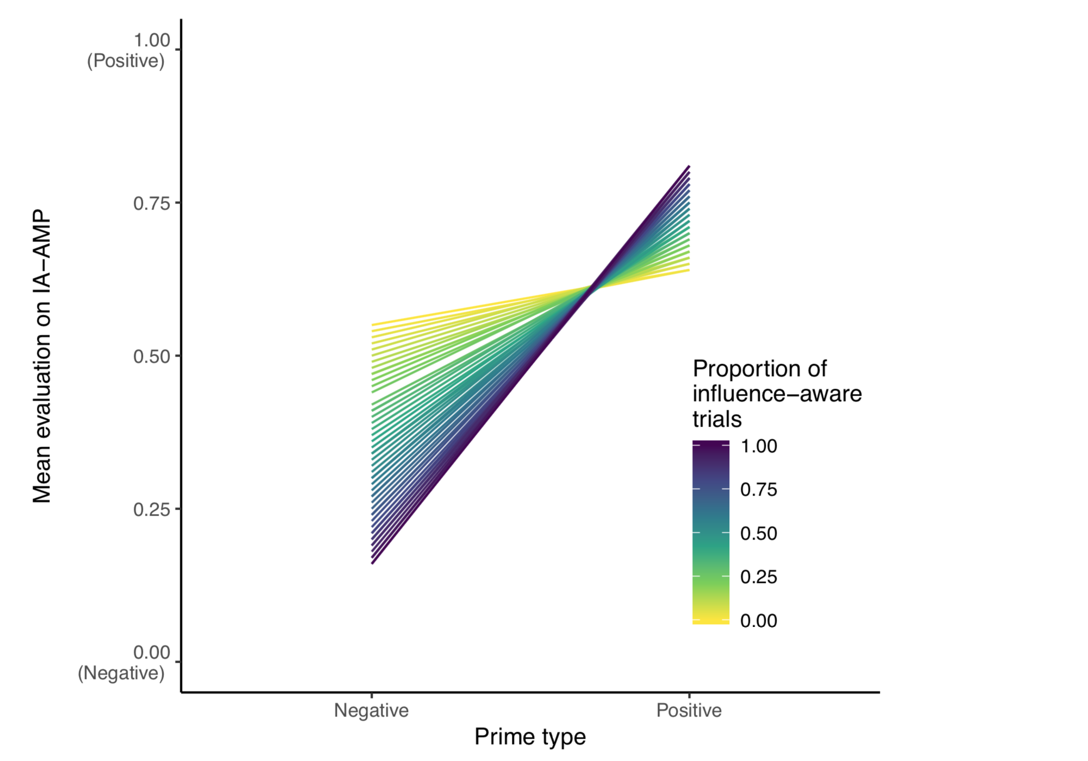

Traditional AMP effects strongly correlated with influence-awareness rate on the IA-AMP, even though

1. Even though the AMP was completed prior to the IA-AMP, cannot be influenced by it.
2. Even when the AMP and IA-AMP are in completely different atttiude domains!

* Beta = 0.43, [0.29, 0.58], *p* <10-8

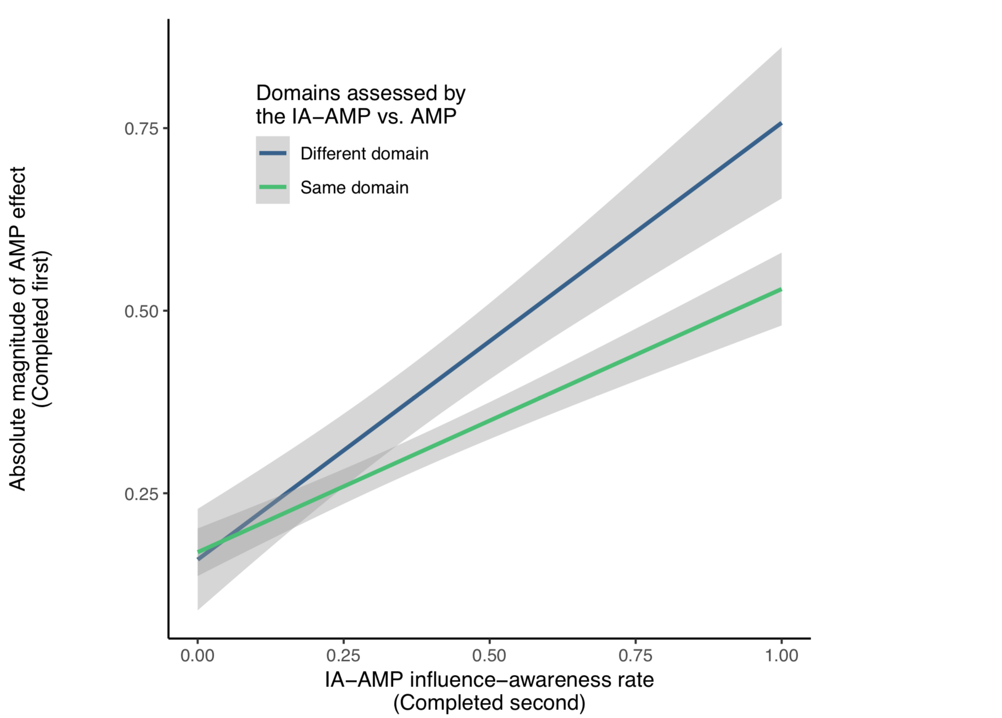

## 

**Experiment 4 – predictive valdiity**

Politics IA-AMP influence-awareness drives its ability to detect known groups differences

* Influence-aware trials: Cohen’s *d* = 2.08 [1.62, 2.55]
* Influence-unaware trials: Cohen’s *d* = 0.62 [0.33, 0.91]
* Difference: *p* = .0000002

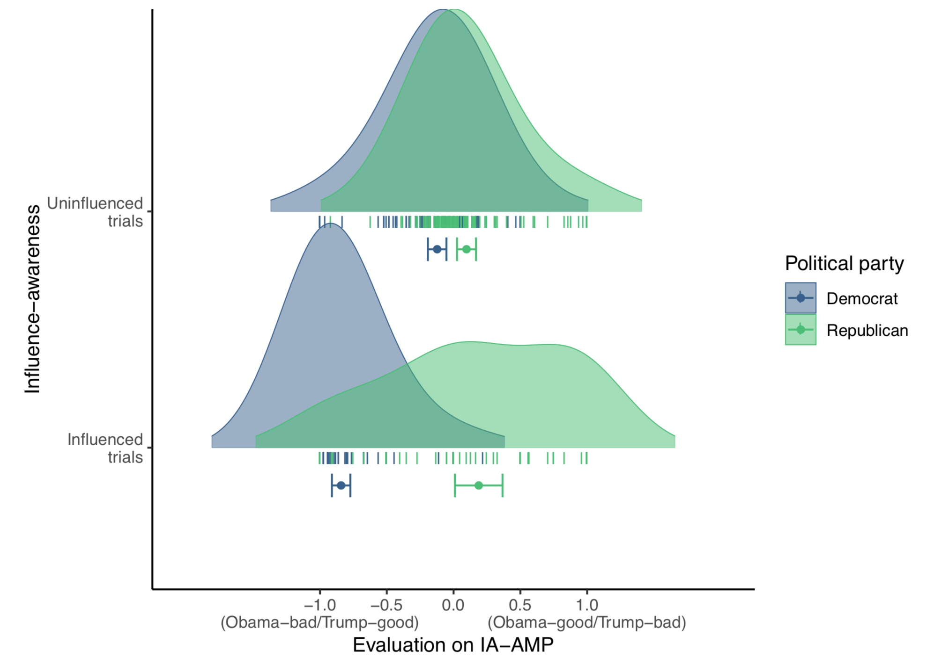

Positive-Negative IA-AMP’s influence-awareness rate predicts difference between known groups on the Politics IA-AMP effect

* Even though the Politics AMP was completed prior.
* Even though the IA-AMPs are in completely different atttiude domains!
* Beta = 1.01 [0.75, 1.27], *p* = .000000000001

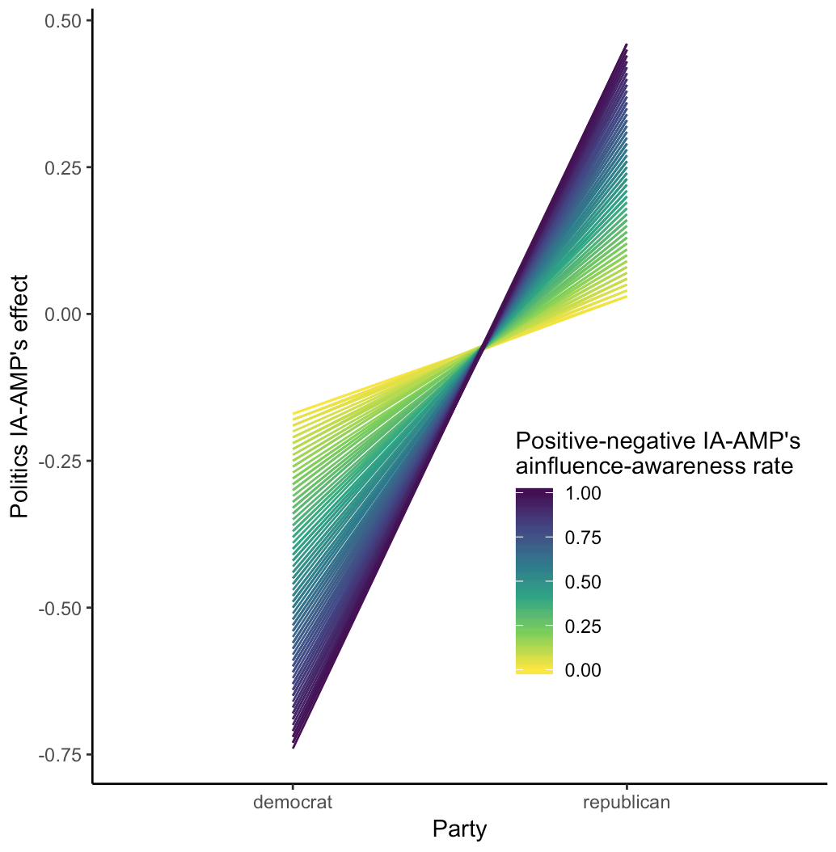

## Implications

AMP is not an implicit measure

* task much less appealing to use

Not mediated by a misattribution process

* Several theories built on AMP effects are undermined:
  + Process model of misattribution (Payne, Hall, Cameron, & Bishara’s, 2010)
  + Claims that evaluative conditioning is based on a misattribution process (Jones et al., 2009)
  + Claimslipl that psychological properties beyond evaluations can also be misattributed (Blaison, Imhoff, Hühnel, Hess, & Banse, 2012).

AMP-derivative tasks undermined

* Semantic Misattribution Procedure (Sava et al., 2012)
* Truth Misattribution Procedure (Cummins & De Houwer, 2019)

Can we continue to use the AMP agnostic to its implicitness?

* Unlikely, as it only captures behaviour in a subset of the population.
* Influence awareness rates correlate highly between two IA-AMPs that assess completely different attitude domains, *r* = 0.82, [0.77, 0.86]. This is higher than then within domain test-retest reliability of many measures!
* The AMP doesn’t measure evaluations (whether or implicit) in participants, only in a consistent subset of participants who are highly influence aware.
* These are a minority of the populartion (e.g., 8% > 90% aware).
* AMP is not an (explicit or implicit) measure of *anything* in most participants.

Reevaluation of previously published results needed

* Someone should do a systematic review (but probably not us?)
* Possibly replication of key effects (but probably not us?)

IA-AMP as an alternative task for the future?

* Only if you can stomach (a) the loss of power/predictive utility and (b) only studying a specific subset of the population.
  + N = 16 needed using influence-aware trials
  + N = 138 needed using influence-unaware trials

## What defines highly AMP influence-aware individuals? Is it a state or trait characteristic?

* Currently unclear.